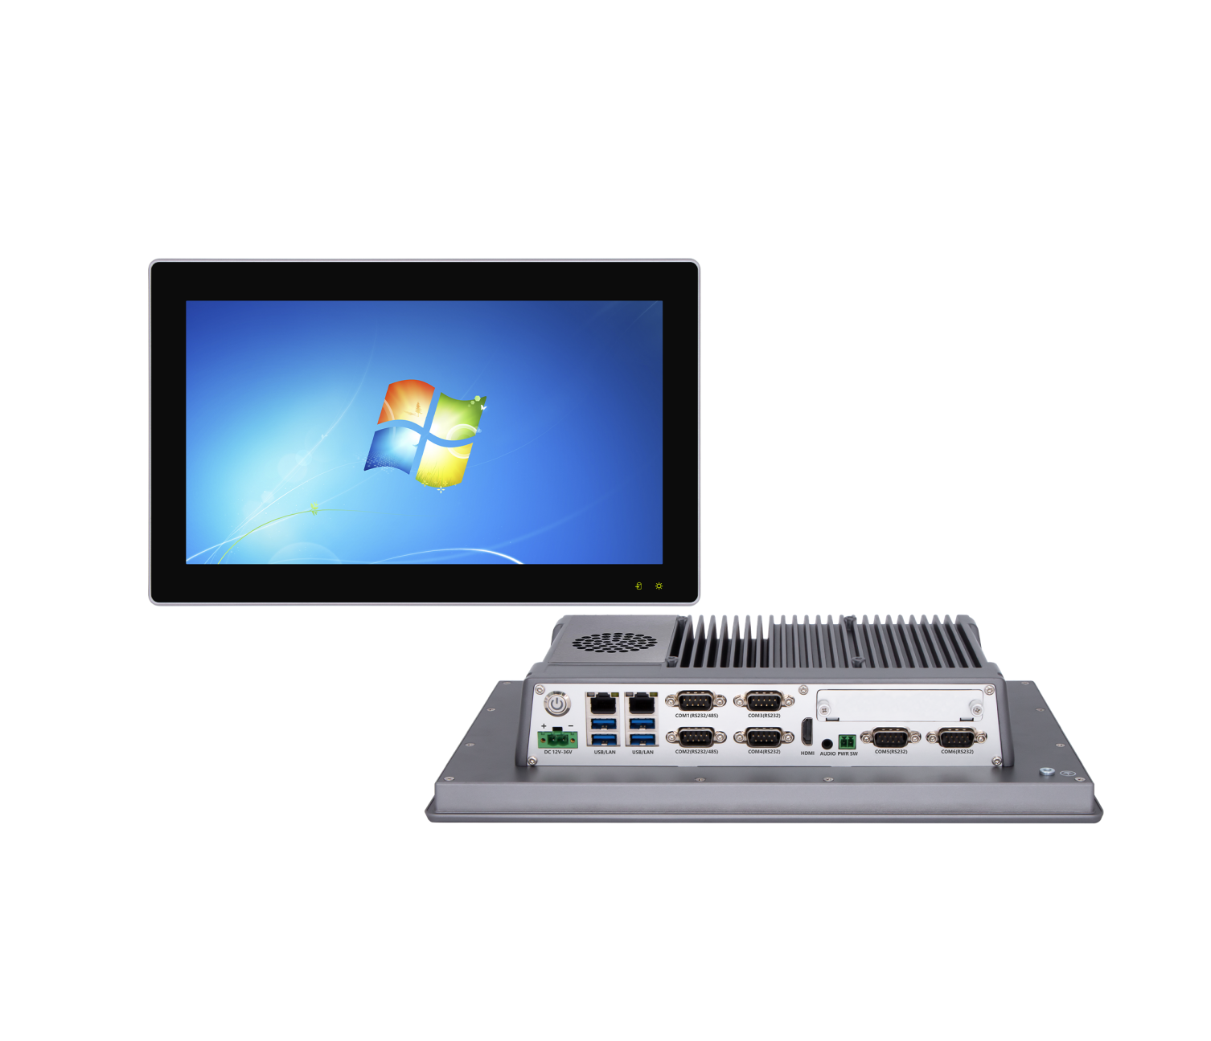

**Industrial Panel PC**

**QY-P8173-DC**

**Products Features:**

1. **Industrial-Grade Embedded Fan Design Panel PC**
2. **17.3 inch LED Screen, Resolution: 1920*1080**
3. **Support Capacitive Touch Screen**
4. **Intel B365 / H670 Chipset**
5. **Intel Celeron / Pentium and Core 6/7/8/9/12/13/14th-i3 / i5 / i7 / i9 CPU**
6. **2*RJ-45, 4*USB, 6*COM, 1*HDMI**
7. **2*Expansion Slots, Support 4G/5G and WIFI module**
8. **DC 9-36V Power Input With Overvoltage Protection**
9. **-20℃~50℃ Temperature Can Keep 24/7 Work Stably**
10. **1*Multifunction Daughter card slot**
11. **Anti-Static, Anti-Pulse, Anti-Surge, Anti-Radiation**

**1. Mother Board Specification:**

**QY-P8173-DC**

|  |  |  |
| --- | --- | --- |
| **Model** | **QY-CFL-B365-8000** | **QY-ADL-H670-8000** |
| **Chipset** | **B365** | **H670** |
| **CPU** | **Celeron**  **Pentium**  **6 / 7 / 8 / 9th-i3 / i5 / i7 / i9** | **Celeron**  **Pentium**  **12 / 13 / 14th-i3 / i5 / i7 / i9 Desktop CPU** |
| **Memory** | **2*DDR IIII RAM Slots, Up to 64GB** | **2*DDR IIII RAM Slots, Up to 128GB** |
| **Storage** | **1*M.2 NVME SSD Slot** | |
| **Display** | **1*HDMI: Resolution up to 4096*2106@24Hz** | |
| **Expansion** | **1*Mini PCIE Slot, Support 4G and WIFI module** | **2*M.2 Slots, Support 4G/5G and WIFI module** |
| **Ethernet** | **2*Intel LAN Chip (10 / 100 / 1000 Mbps, RJ-45 Type)** | |
| **USB** | **4*USB 3.0 (Type-A)** | |
| **COM** | **2*RS-232 / 422 / 485 (DB9 type)**  **4*RS-232 (DB9 ype)** | |
| **Audio** | **1*Line-Out** | |
| **Daughter Card** | **Support expansion more I/O interfaces and functional slots** | |

**2.Screen Specification:**

|  |  |
| --- | --- |
| **Screen Size** | **17.3 inch TFT LED Screen, 16:9 Size** |
| **Resolution** | **1920*1080** |
| **Brightness** | **350nits** |
| **Contrast** | **800:1** |
| **Largest Colorful** | **16M** |
| **Touch Screen Type** | **Capacitive** |
| **Transmittance** | **More than 95%** |
| **Touch Life** | **50 million times** |
| **Response Time** | **＜5ms** |
| **Touch Hardness** | **7 Mohs** |
| **Protection** | **Front Panel IP65 Water Proof** |

**QY-P8173-DC**

**QY-P8173-DC**

**3.Device Specification:**

|  |  |
| --- | --- |
| **Power Input** | **DC 9-36V with overvoltage protection** |
| **Support Auto-Start** |
| **2 Pin Phoenix Terminal type DC Plug** |
| **Structure** | **Fully Enclosed Aluminum Alloy Material** |
| **Heat Dissipation** | **Fan Design** |
| **Installation** | **Desktop / Embedded / Wall Mount** |
| **Size** | **435mm*265.5mm*71mm** |
| **System** | **Windows and Linux** |

**QY-P8173-DC**

**4.Optional Specification:**

|  |  |  |
| --- | --- | --- |
| **Screen** | **Brightness** | **Optional 1000 nits LED screen** |
| **Optional brightness auto adjustment function** |
| **Anti-Glare** | **Optional** |
| **Camera** | **Optional 200w or 500w camera (Built-in front panel)** |
| **Full Lamination** | **Optional** |

**QY-P8173-DC**

**5.Daughter Card Specification:**

|  |  |
| --- | --- |
| **COM Port-2** | **2*RS-232 / 485 (DB9 type)** |
| **COM Port-6** | **4*RS-232 / 485+2*RS-232 (Phoenix terminal type)** |
| **Ethernet Port-2** | **2*Intel i211V LAN Chip (RJ-45 type)** |
| **Ethernet Port-4** | **4*Intel i211V LAN Chip, Support POE function (RJ-45 type)** |
| **10G Ethernet Port-2** | **2*10Gbps Ethernet Ports** |
| **USB Port-4** | **4*USB 3.0 (Type-A)** |
| **GPIO Port-14** | **14 ports GPIO, 7*GPI+7*GPO, 0-3.3V (Phoenix terminal type)** |
| **DIDO Port-16** | **16 ports DIDO, 8*DI+8*DO, 24V (Phoenix terminal type)**  **Comes with 4*RS-485 COM ports (Phoenix terminal type)** |
| **Mini PCIE Slot-2** | **2*Mini PCIE slots, Support 4G and WIFI module** |
| **M.2 Slot-1** | **1*M.2 Key-B slot, Support 5G module** |
| **M.2 NVME SSD Slot-1** | **1*M.2 NVME SSD slot** |
| **SATA SSD Slot-1** | **1*SATA 3.0 SSD Slot, Support RAID 1** |
| **CAN Port-2** | **2*CAN interfaces (Phoenix terminal type)** |
| **UPS battery** | **1.2AH or 4.8AH** |

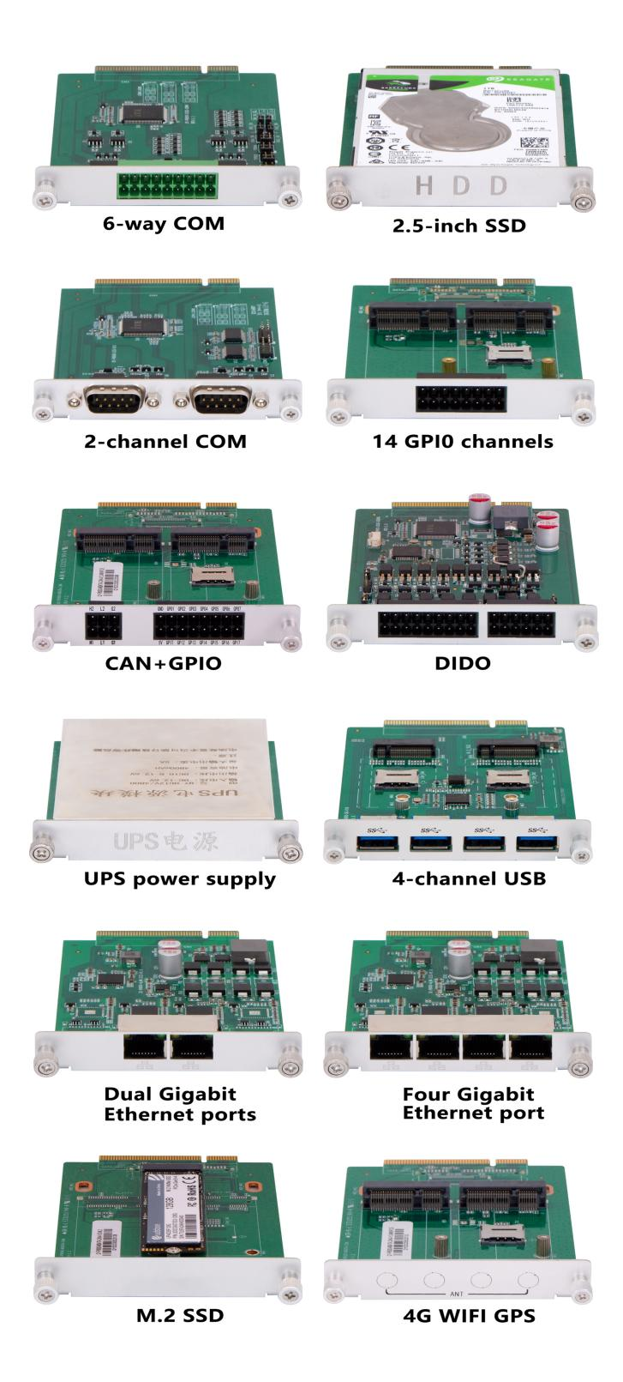

**QY-P8173-DC**

**6.Ordering Information:**

|  |  |  |  |  |  |  |  |  |  |
| --- | --- | --- | --- | --- | --- | --- | --- | --- | --- |
| **Model** | **CPU** | **LAN** | **USB** | **COM** | **RAM** | **Display** | **SSD** | **Expansion** | **Power** |
| **QY-P8173-DC** | **B365** | **2** | **4** | **2*RS-232/422/485**  **4*RS-232** | **2*DDR 4**  **Up to 64GB** | **1*HDMI** | **1*M.2 NVME** | **1*Mini PCIE** | **DC 9-36V** |
| **H670** | **2*DDR 4**  **Up to 128GB** | **2*M.2** |

**7.System Information:**

|  |  |
| --- | --- |
| **CPU** | **System** |
| **6th / 7th** | **Windows 7 / 10 and Linux** |
| **8th / 9th / 12th / 13th / 14th** | **Windows 10 / 11 and Linux** |

**8.Fittings Information:**

|  |  |  |
| --- | --- | --- |
| **RAM** | **DDR 4** | **4GB / 8GB / 16GB / 32GB** |
| **SSD** | **M.2 NVME** | **128GB / 256GB / 512GB / 1TB / 2TB / 4TB** |
| **SATA** | **120GB / 128GB / 240GB / 256GB / 480GB / 512GB / 960GB / 1TB / 2TB / 4TB** |
| **GSM Module** | **4G** | **4G+GPS** |
| **5G** | **5G+GPS** |
| **WIFI Module** | **7260AC / AX210** | |
| **CAN BUS Module** | **2 ports CAN BUS interfaces** | |

**9.Package List:**

|  |  |
| --- | --- |
| **Adapter** | **1*12V 10A Adapter** |
| **Power Cable** | **1*Power Cable** |
| **Mount Clamp** | **4*Mount Clamp** |

**QY-P8173-DC**

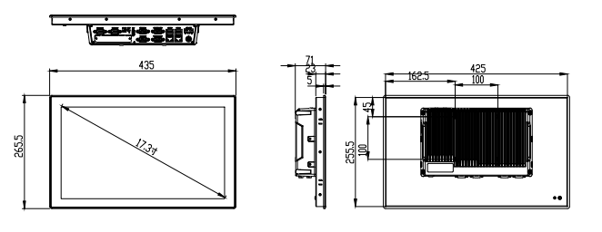

**10.Dimensions:**